No Sew Fleece Scarf
What you Need:
1.5 yards of fleece fabric
scissors
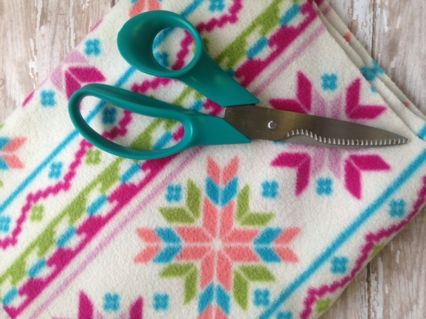
Please note: The length of fleece you use for this project is an estimate. Yours may vary based on your own preferences and size. For children you may use less, while for adults you may wish for more. The suggested amount is ideal for an adult and a great starting point.
Directions:
1. Begin by laying the fabric flat. Cut the fabric so it is about 8-10 inches wide.
2. Take your cut fleece and lay it flat so you can start snipping the fringe on the ends.
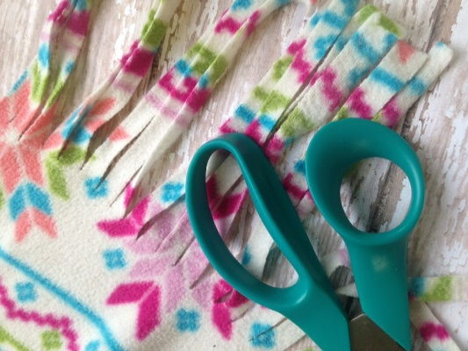
3. Cut the ends of each side of the fabric into strips as shown. You want them to be about 3 inches long and about 1 inch wide. You can adjust these measurements as you wish according to your liking.
4. Finish the fringe by tying each strip into a knot. Just tie it into itself, loop, and pull.
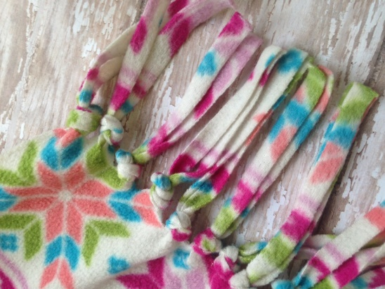
5. Repeat by tying each strip until all are secure.

